Introduction
This document describes setup for Forum demo.
Source code can be found in https://github.com/jacobborella/apicurio.repo.

Setup nexus
Follow
https://docs.openshift.com/container-platform/3.5/dev_guide/app_tutorials/maven_tutorial.html

Settings in screen
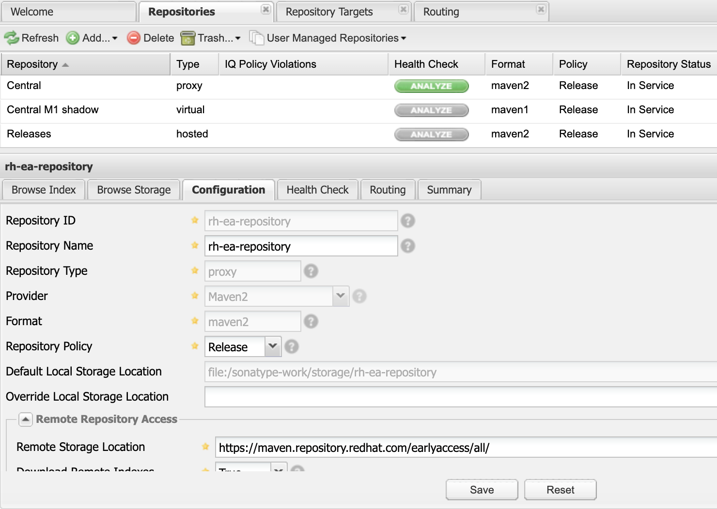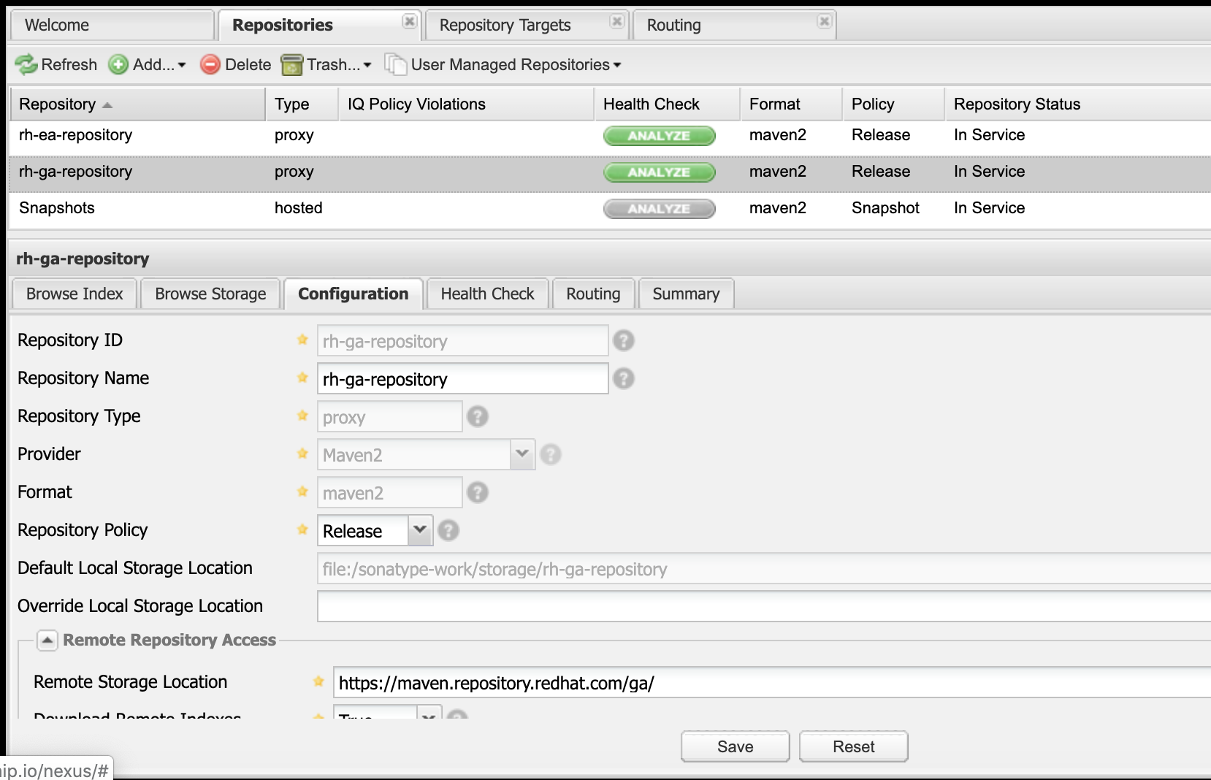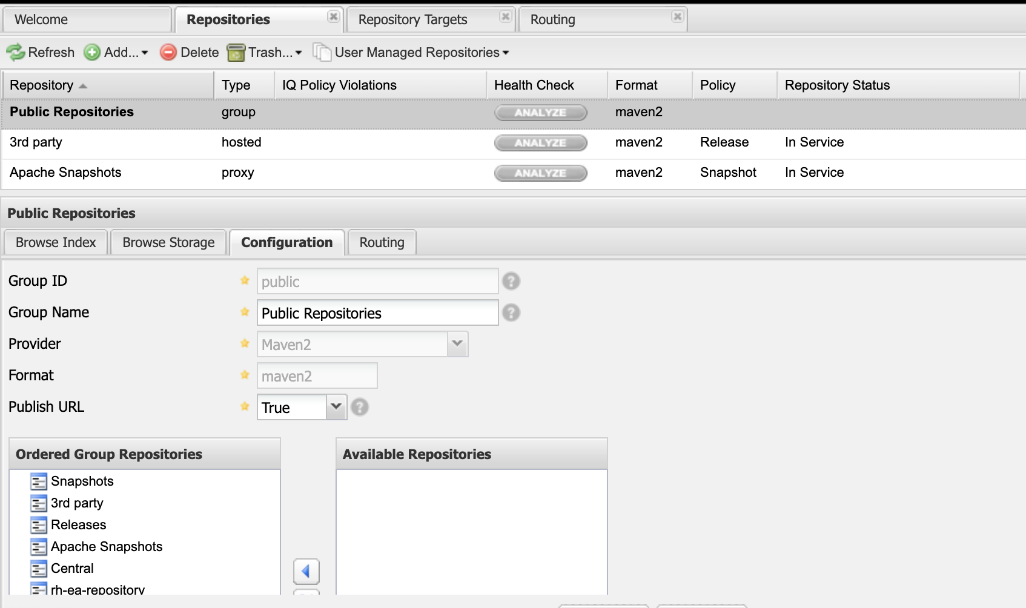

Create demo-repository
Id + name demo-repository
Allow redeploy

Setup Jenkins
https://dzone.com/articles/jenkins-publish-maven-artifacts-to-nexus-oss-using

- Install Jenkins from Catalog
- Setup config file for pointing to nexus repo
  - Goto manage Jenkins -> managed files
  - Add new config
    - Type maven settings.xml
    - Id ‘mvn-nexus-config’
    - Paste content from artifacts/settings.xml
  - 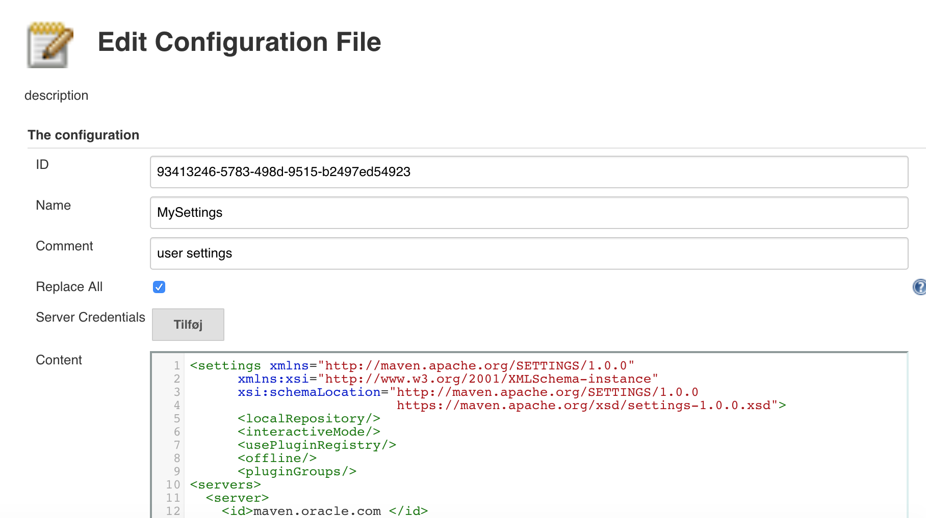
  - Save
- Add secret for nexus user
  - Manage Jenkins -> configure credentials -> Credentials -> add domain
    - Domain name ‘demo’
  - Add credentials
  - 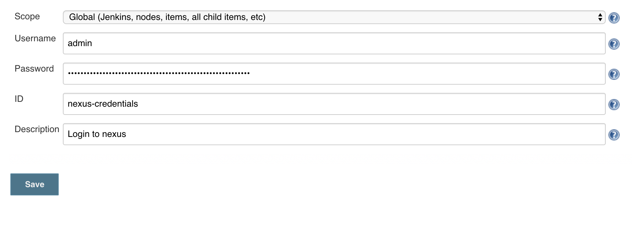
- Add plugin
  - Manage jenkins -> plugin manager -> available
  - Find ‘Nexus Artifact Uploader
  - Install it without restart
- Setup pipeline
  - Oc create -f pipeline.yaml
  - Create webhook in git
    - Webhook url is https://18.196.187.53.nip.io:8443/oapi/v1/namespaces/demo-cicd/buildconfigs/sample-pipeline/webhooks/ra68uhdf98h4tn123/github
    - Content-type: application/json
    - Disable ssl verify
    - Resend package
- Change necessary variables in the pipeline

Useful links
https://access.redhat.com/documentation/en-us/red_hat_fuse/7.4/pdf/designing_apis_with_apicurito/Red_Hat_Fuse-7.4-Designing_APIs_with_Apicurito-en-US.pdf
https://www.apicur.io/

Practical stuff

